Fitting molecular dynamic potentials to inelastic neutron data

Abstract

Introduction
The aim of MDMC is to produce a move of the atoms to understand dynamical properties of materials. An important part of this process involves the fitting of MD potential energy parameters against S(Q,omega) data.
Argon is a model material for which there is a high quality S(Q,omega) dataset available.
Reference to Alan Soper work -> fit of potential shape to S(Q) data using MC
Reference to Gereben/Pusztai/McGreevy -> RMC and S(Q,omega).

MDMC

Method
The method follows the following simple steps
- Initialize potential energy (PE) parameters. Run initial MD simulation. Calculate S^{cal}(Q,omega) and FOM agreement of this function with S^{obs}(Q,omega)
- Store initial FOM value and phasespace configuration
- Select new PE parameters
- Run MD, calculate S^{cal}(Q,omega) and FOM
- Use the Metropolis criterion to either accept or reject the phasespace configuration of 6 based on comparing the value of the new and previously calculated FOM value. If rejected the phasespace configuration is reset to the previous configuration. If accepted the FOM and phasespace configuration of 6 is stored.
- Return to 5 until convergence has been achieved.
In this work the shape of a MD potential is adjusted against dynamical structure factor S(Q,omega) data. Such data can be obtained from neutron diffraction experiments. S(Q,omega) is related to the time-dependent pair distribution function G(r,t) through the Fourier transform

Ignoring Quantum effects then in the classical limit G(r,t) for a mono-particle sample is

This function tells have the particle moves with respect to each other (and themselves) and G(r,t) is readily calculated from a MD simulation. The thermal average <> in Eq. (grt) is calculated by averaging over statistical independent (or nearly independent) G(r,t) instances (typically 20), where each G(r,t) is calculated using the approach in Ref. [Rapaport], which consists of calculating a sequence of particle r-binned histograms for different t values.
When comparing with neutron data in general, it is necessary to split the summation in Eq. (grt) up into a self-part and distinct-part. The self-part is

And the distinct part is Gd=G-Gs. The reason for requiring this splitting is that the neutron cross section is proportional to

Where Ss is the Fourier transform of Gs. (Although to compare with neutron data only the f.t. of Gs and G are needed, it can be informative to plot Gd(r,t) to spot characteristics of the sample under study that may spot by visualising only S(Q,omega).

Calculation details
The MD module together with significant parts of the code for calculating S(Q,omega) follows the approach in Rapaport, 2004.
- Significant advantage -> running in non-equilibrium
- Running with reduced box size.

Initial results
Figure (Ag DATA) shows S(Q,omega) data of liquid Ar, T=120K and rho=0.0176AA-3 (van Well et al., 1985). A simulation was run where the aim was to fit the parameters of the Lennard-Jones potential
i.e. epsilon and sigma against van Well’s Ar data. The initial values for the potential energy parameters where set to epsilon=1.5K/mol and sigma=4.0AA, which as can be seen from Figure (Ag Grt crystal), showing a simulation of G(r,t), correspond to Ar being crystalline. These parameter are then allowed to randomly change between +-0.1 for each MC step. Figure (Ag Grt liquid) shows the best G(r,t) after 400 MDMC steps, and in Figure (Ag Sqomega) the corresponding S(Q,omega). Also, in Figure (Ag diff-a) the difference between observe and calculated S(Q,omega) is shown. Figure (Ag FOM-a) shows the logarithm of the FOM as a function of the MC step number. As can be seen the convergence from crystalline Ag to a liquid Ag state that fits the data well happens for this case within the first 20 MC moves. Also after 400 MC steps the T_{MC} parameter is reduced by a factor of 4, which results is a lowering of the FOM fluctuations but not in finding a new improved liquid Ag state. Also (b) shows the values of sigma and epsilon for the all the accepted FOM past the 20th accepted move.

Discussions
Could as well use S(Q) or a combination.

Conclusions

Acknowledgements
Many thanks goes to Keith Refson for advising on how to get started with writing a molecular dynamics module.

References
D. C. Rapaport, “The Art of Molecular Dynamics Simulation”, 2nd ed., Cambridge University Press 2004.
A. A. van Well et al., Phys. Rev. A31, 3391 (1985)

Captions

Figure (Ag DATA): Shows un-symmetried version of van Well’s Argon data, i.e. where the data in blah blah have been multiplied by exp(0.5*hbar*omega/kB*T).
FIGURES
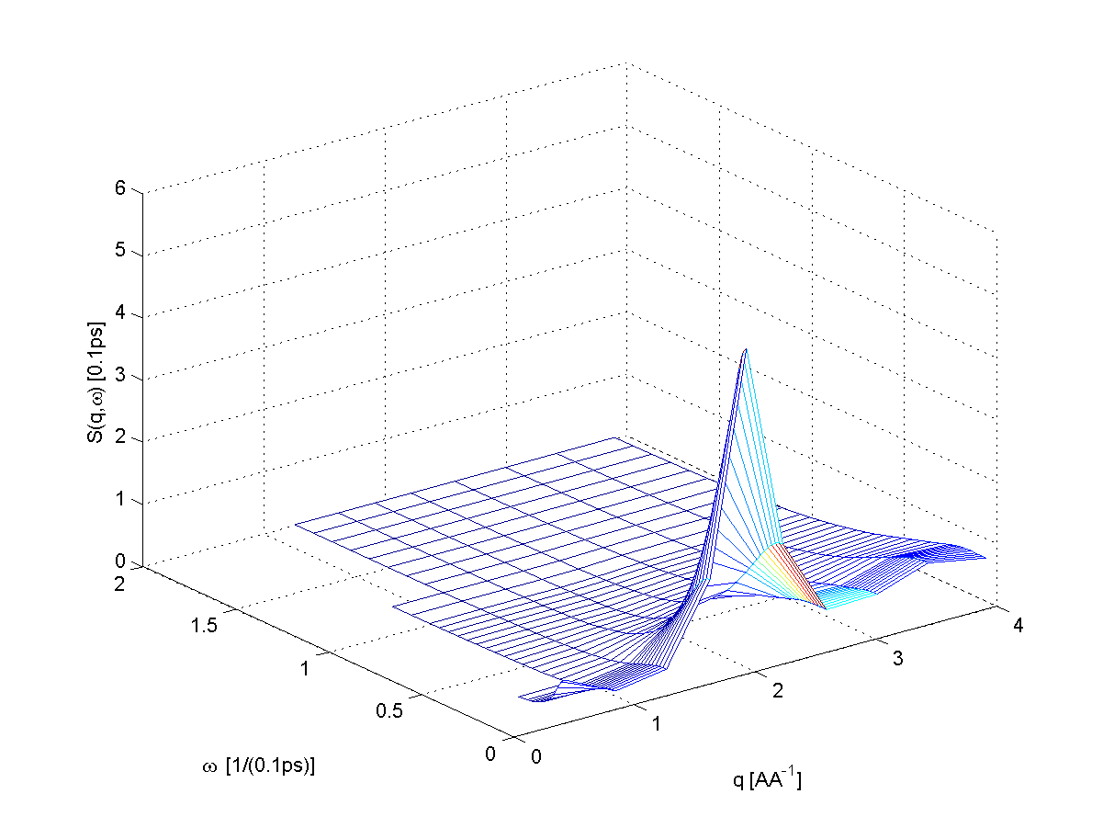
Figure 1 (Ag-DATA)

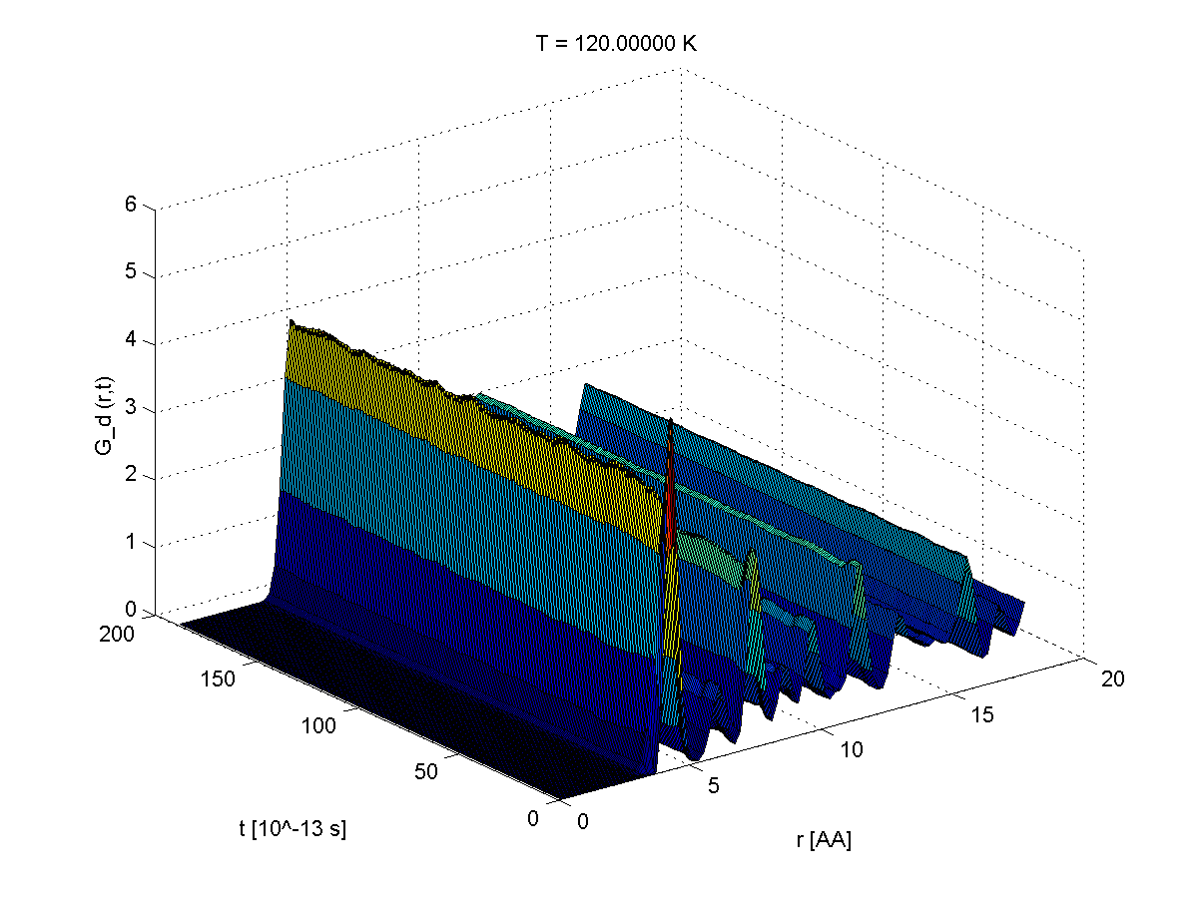
Figure 2 (Ag Grt crystal)

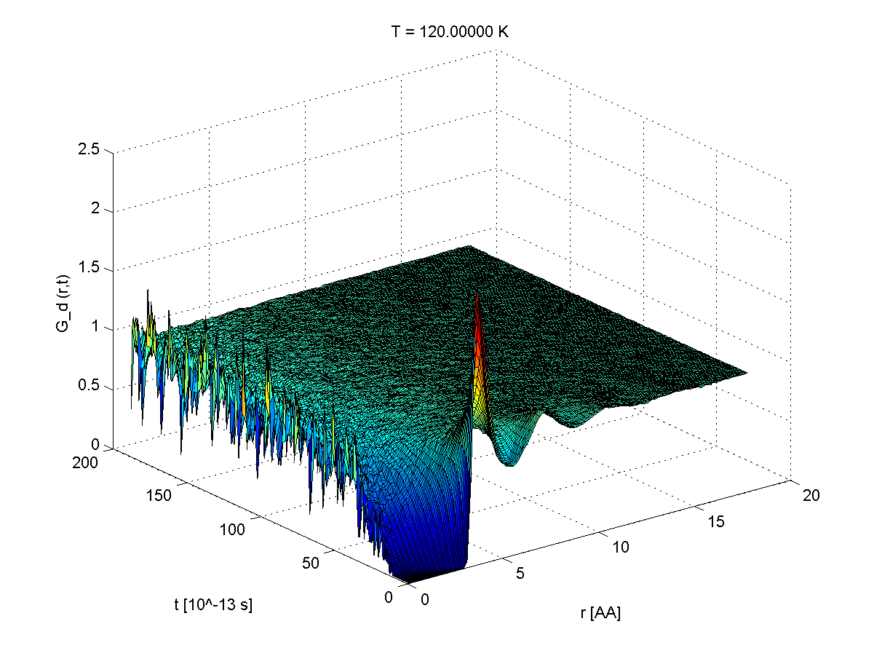
Figure 3 (Ag Grt liquid)

